Multilevel model with entity and time effects

**Labor force participation rate**

Female Male Gender Gap

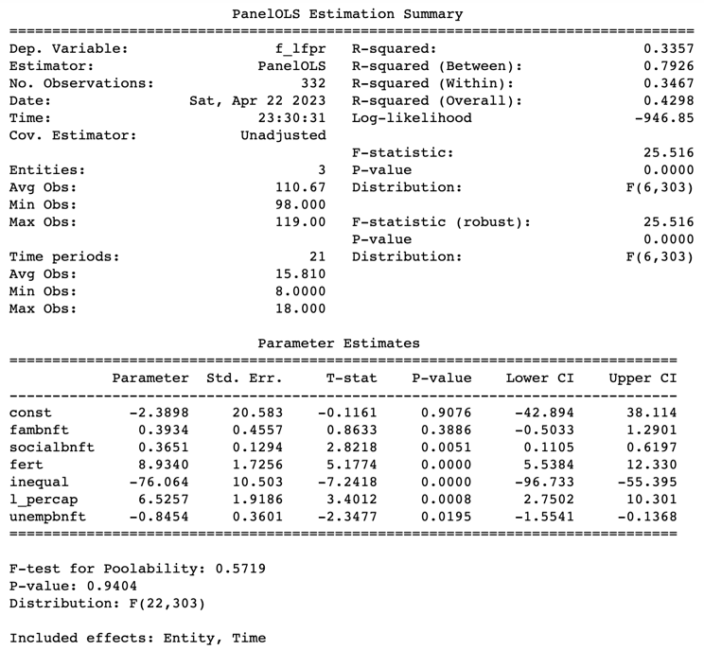

**Unemployment rate**

Female. Male Gender Gap

